**FIREBASE STORAGE:**

**Stored in firebase:**

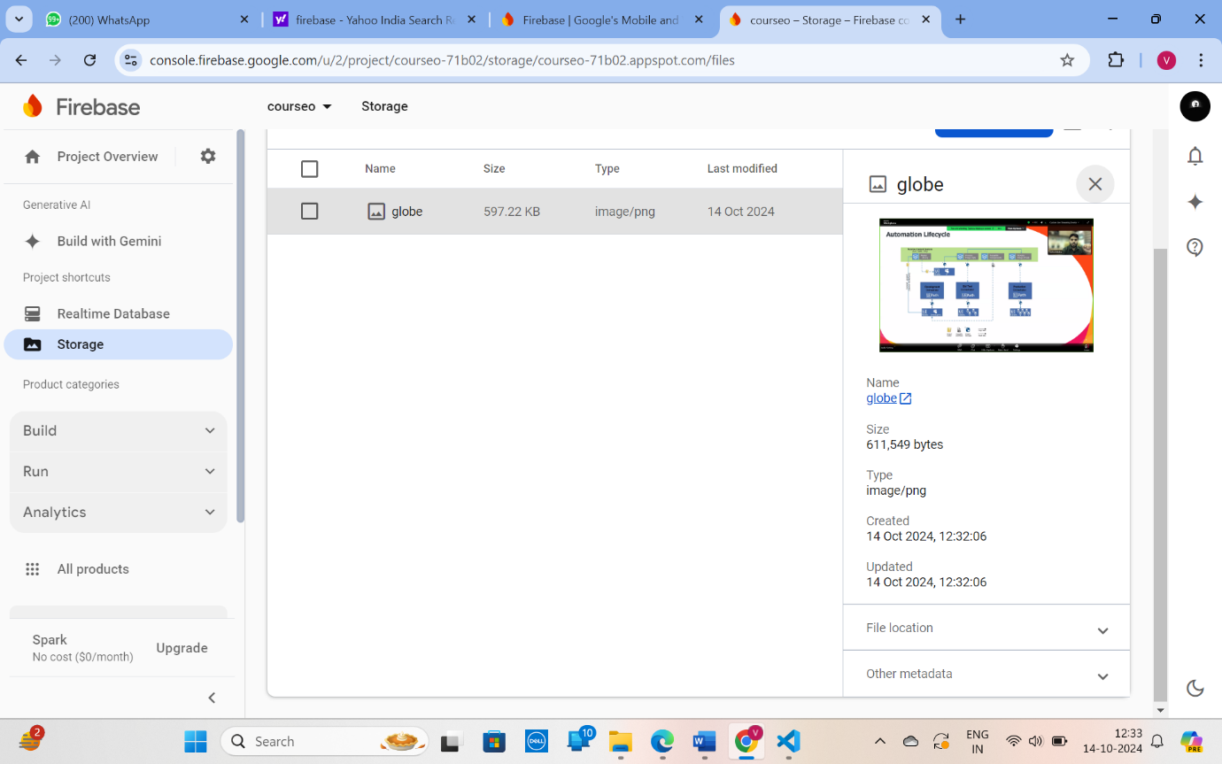

**Uploaded in the web:**

